Title Research head line 16…………………..
Author ------¹, Author^{,2-------------------------.}
^{1,2}Department of --------, College of ---------, University of --------, City, Country

Article information |  | ABSTRACT
Received: **/**/20**  Revised: **- ** -20**  Accepted: **/**/20**  Available online:**/**/20** |  | Times New Roman 10 ……………………………  Times new Romman 10 …………………………..
Keywords:
*****
*****
3-5 words

Correspondence:
Name: ********
Email ---------@gmail.com

Note: Do not write the authors’ names, affiliation, or even email under the title, at the top of the page, or in the correspondence, in both languages.

عنوان البحث بحجم 16
الباحث الاول¹ ---------، الباحث الثاني² ---------. حجم 12
^{1،2} قسم علوم -------، كلية -------، جامعة --------، المدينة، البلد حجم 12 مائل

الملخص |  | معلومات الارشفة
حجم الخط في الملخص العربي 10 Simplified Arabic........  حجم الخط في الملخص العربي 10 Simplified Arabic........  حجم الخط في الملخص العربي 10 Simplified Arabic........ |  | تاريخ الاستلام: **/**/**20  تاريخ التعديل: **/**/**20  تاريخ القبول: **/**/**20  تاريخ النشر الالكتروني: **/**/**20
الكلمات المفتاحية:
******
******
3-5 كلمات مفتاحية
المراسلة:
الاسم: ----------------------------
Email--------@gmail.com

ملاحظة:
- عدم كتابة أسماء الباحثين او مكان عملهم او حتى الايميل تحت العنوان او في رأس الصفة او في المراسلة وبكلا اللغتين في متن ملف البحث
- عدم ادراج الجداول او المعادلات بشكل صورة نهائيا

Introduction
The text that is prepared on all the research and from here on each researcher after he writes the entire research what he has to do except make copies of the entire search and from its original file and copy it to this file and then format it on this file after pasting his research in it…………………………………….. etc.

Aim of study
The text that is prepared on all the research and from here on each researcher after he writes the entire research what he has to do except make copies of the entire search and from its original file and copy it to this file and then format it on this file after pasting his research in it…………………………………….. etc.

Insert the Figures below

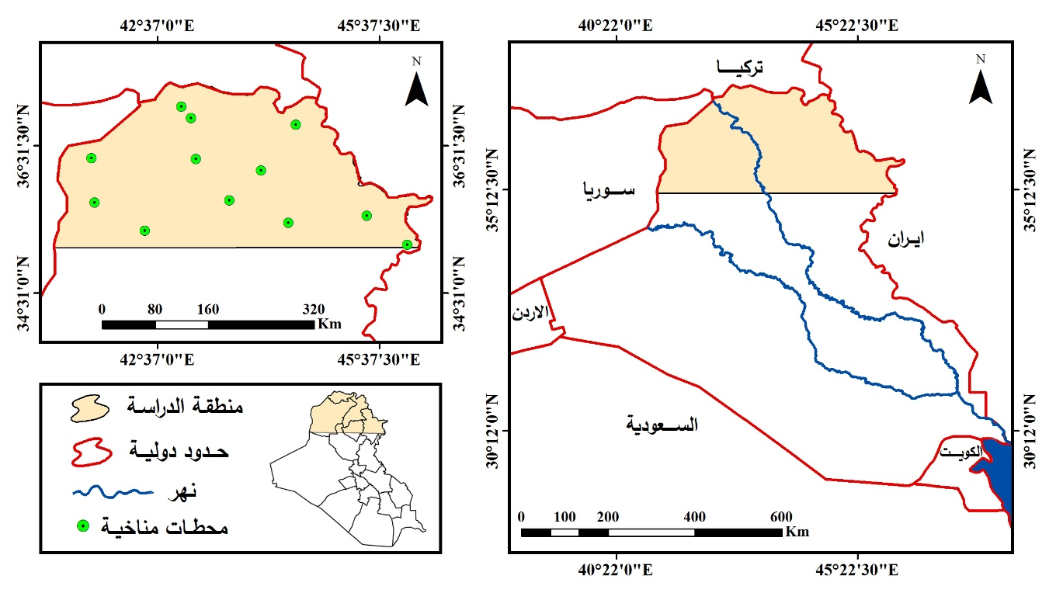
Fig. 1. …………… line 10 time new roman ………………………….

كتابة الجداول تكون بالصيغة الاتية

Table 1: ……………line 10 time new roman ……not insert image……………………………..
ت | ……….. | ……………………………………………… | ……………………………. | ……………………………
1 | …….
2
3
4
5
6
7
8
9
10
11
12

الجدول 2. مدى التغيرات في معدلات التساقط المطري السنوي (mm) بين المُدد الثلاث لمحطات منطقة الدراسة.
ت | اسم المحطة | خطوط الطول | دوائر العرض | معدل المدة الاولى (1992-1982) | معدل المدة الثانية (2003-1993) | معدل المدة الثالثة (2014-2004)
1 | الموصل | 43.13721 | 36.34551 | 478.81 | 348.72 | 255.09
2 | مخمور | 43.59281 | 35.78181 | 372.55 | 262.56 | 219.51
3 | البعاج | 41.76331 | 35.74981 | 363.17 | 282.94 | 232.10
4 | الحضر | 42.4351 | 35.34.22 | 190.68 | 149.08 | 147.75
5 | كركوك | 44.39521 | 35.47351 | 440.81 | 315.48 | 234.92
6 | اربيل | 44.02161 | 36.18611 | 726.99 | 462.92 | 474.15
7 | سنجار | 41.72001 | 36.35441 | 518.61 | 413.94 | 379.08
8 | زاخو | 42.94151 | 37.05571 | 573.96 | 445.47 | 447.90
9 | دهوك | 43.07451 | 36.89951 | 696.67 | 523.94 | 424.34
10 | راوندوز | 44.49951 | 36.81311 | 1187.95 | 891.39 | 939.95
11 | السليمانية | 45.46081 | 35.57181 | 903.13 | 658.78 | 705.42
12 | حلبجة | 46.01021 | 35.17321 | 579.25 | 430.18 | 351.33

Materials and Methods
The text that is prepared on all the research and from here on each researcher after he writes the entire research what he has to do except make copies of the entire search and from its original file and copy it to this file and then format it on this file after pasting his research in it…………………………………….. etc.
Results
The text that is prepared on all the research and from here on each researcher after he writes the entire research what he has to do except make copies of the entire search and from its original file and copy it to this file and then format it on this file after pasting his research in it…………………………………….. etc.
Discussion
The text that is prepared on all the research and from here on each researcher after he writes the entire research what he has to do except make copies of the entire search and from its original file and copy it to this file and then format it on this file after pasting his research in it…………………………………….. etc.

Conclusion
The text that is prepared on all the research and from here on each researcher after he writes the entire research what he has to do except make copies of the entire search and from its original file and copy it to this file and then format it on this file after pasting his research in it…………………………………….. etc.

Acknowledgments

Conflict of Interest

References

Abu Radi, F.A.A., 2000. Quantitative methods in geography, Alexandria, Dar Al-Marefa Al-Jami`iyyah, 493 pages. (In Arabic)

Abu Radi, F.A.A., 2004. The Foundations of climatic and botanical geography, first edition, Beirut, Dar Al-Hadba Al-Arabiya, 584 pages. (In Arabic)

Al-Azzawi, A.A.A., 2019. Evaluation of spatial prediction maps for rain in northern Iraq using GIS techniques, Midad Al-Adab Journal, special issue of conferences 2018-2019, pg. 941-962. (In Arabic)

Alhashimi, S.A.M., 2014. Prediction of Monthly Rainfall in Kirkuk Using Artificial Neural Network and Time Series Models, Journal of Engineering and Development, Vol. 18, No.1, pp. 129-143.

Al-Shibli, H.F.A., 2006. Spatial and temporal distribution of precipitation patterns in Iraq, Ph.D. thesis (unpublished), Al-Mustansiriya University, College of Education, 217 pages. (In Arabic)

Al-Soul, A.A.S., 2007. Fluctuation and Variation in Rain Rates in the Popularity of Misurata and the Possibility of Exploiting It, Unpublished Master’s Thesis, Seventh of October University, Faculty of Arts, Libya, 209 pages. (In Arabic)

Al-Sumaida'i, A.A.K., 2005. Modeling rainfall in the mountainous region of Iraq using remote sensing data, unpublished master's thesis, Tikrit University, College of Education, 127 pages. (In Arabic)

Ayad K. H., 2014. Best Distribution and Plotting Positions of Annual Rainfall in the Catchment of Holy Karbala in Iraq, Journal of Babylon University/Engineering Sciences, No. 4, Vol. 22, pp. 894-906.

https://globalweather.tamu.edu/, Global Weather Data for SWAT, 1982-2014.

Koppen, W., and Geiger, R., 1928. Climate Classification world map.

Sanchez F.J., Chris, M.M., and Victor, J., 2013. Influence of topography on rainfall variability in Santiago Island, Cape Verde, International Journal of Climatology, pp. 1-17.

ملاحظة : يجب كتابة DOI: لكل بحث

