Very important note: Use the styles provided within the template to format the search as required.
ملاحظة مهمة جدا جدا ..استخدم الانماط الموجودة ضمن القالب لتنسيق البحث بالشكل المطلوب

Title of the Manuscript
First Author ¹,  Second Author ^{2*}, Third Author ³, (12pt)
firstl@uomosul.edu.iq second2@uomosul.edu.iq third3@uomosul.edu.iq

¹ Department of --------, College of ---------, University of --------, City, Country (9 pt)
² Department of --------, College of ---------, University of --------, City, Country (9 pt)
³ Department of --------, College of ---------, University of --------, City, Country (9 pt)

Received: March 10th, 20** Received in revised form: Novamber 20th, 20** Accepted: February 10th, 20**
Available online: 00- Dec – 20**

ABSTRACT (Italic, Bold, 10pt)
Fundamentally, the current study is concerned with the investigation and diagnosis of Ostracoda fossils from the subsurface section of the Hartha Formation (Late Campanian - Early Maastrichtian) from the Ba-8 well at central Iraq. Fifty-nine Ostracoda species belonging to (29) genera/ subgenera from (13) families are diagnosed and classified to their ranks according to the standard systematic paleontology. Whereas (57) species are attributed to species previously described from local and regional studies. Two species are left under open zoological nomenclature basically because of a lack of specimens. As a result, the study inferred that the species diagnosed in the Hartha Formation belong to the Late Campanian - Early Maastricht. These species are very similar in terms of external appearance and geologic age to the same species that were compared with them and which were previously described in the regions of East, West, and North Africa, as well as the Arabian Gulf region. (Italic, 9 pt).
Keywords:
First keyword; Second keyword; Third keyword; Fourth keyword; Fifth keyword. (Italic, 9 PT)

DOI: *******************, ©Authors, 2026, College of Science, University of Mosul.
This is an open-access article under the CC BY 4.0 license (http://creativecommons.org/licenses/by/4.0/) .
=============================================================================

- INTRODUCTION (10 PT)
Sanam salt dome is a piercement salt plug as a dome structure (Soltan, 2020, Al-Ali et al., 2022). It belongs to the Hormuz Series in the Arabian Gulf region, whose age is estimated to be Infra- Cambrain (Al-Bassam, 2011). Sanam salt plug is composed of sedimentary rocks in addition to igneous and metamorphic rocks intruded with in the evaporite rocks. These rocks have subjected to various geological processes of different degrees that affected their original rock characteristic such as diagenesis, metamorphism, deformation, and dissolution (Soltan, 2020). Jabal Sanam is an important feature due to the importance of salt dome and the presence of oil and tar reserves (Talbot, 2009). Sanam salt dome is composed mainly of gypsum, limestone, dolostone and green marl with vary scarce of igneous rocks, the origin of the rocks within the Sanam salt plug is still under debate. The lower part of the salt plug is composed of diverse sedimentary rocks, which form the central parts (Soltan, 2002); they may have undergone processes of regional metamorphism due to their depth of about (10) km (Al-Hamadani et al., 2005). Several types of carbonate rocks exit in Sanam salt plug are carbonate breccia, dolomite, stromatolitic dolomite and gypsiferrous dolomite (Al-Mudafar, 2019). Dolomite rocks, which are the focus of this study, have few previous mineralogical and petrographic studies, but not been subjected to systematic geochemical study yet. Therefore, the current research aims to conduct the mineralogy and geochemistry of the carbonate rocks in order to give an idea about their origin.
- GEOLOGICAL SETTING
Sanam salt dome is situated within Dibbdiba Plain, which belongs to Mesopotamian zone in unstable shelf area (Buday & Jassim, 1987). It’s a peircement salt dome, whose upper part rocks are exposed on the surface in southern Iraq, and consist mainly of limestone, dolostone, gypsum and marl (Soltan, 2002). The exposed rocks formed a complex component cap rocks, and represented usually the upper part of salt cylinder body, which often consists mainly of evaporates (Billings, 1972). The cap rock does not take the form of one regular dome, its layer tilts away from its top, but rather it is a group of parasitics domes clustered together giving the dome a semi-oval shape. The long axis of Sanam dome is 1.7 km toward NW-SE and the short axis is 1.2 km toward NE-SW (Al-Muttory, 2002). Sanam dome is surrounded by Dibdibba Formation sediments, which are composed of a mixed sand, mud, gypsum, and gravel overlaid by 1-3 m of gypcrete overburden (Al-Ali and Al-Khafaji, 2023).
- METHODOLOGY
Ten samples of carbonate rocks are collected from three selected stations within outcrops in the Sanam salt dome at the southwest of Basra Governorate, near the Iraqi-Kuwait border (Fig. 1). The distance between sample and another vary depending on the lithological changes. Seven thin sections are prepared in University of Tehran work shop and then the mineral composition are identified by polarizing microscope type OPTIKA in the laboratories of Department of Geology, College of Science, Basra University. XRD (X-Ray Diffraction) technique type panalytical PW3830 X-ray generator is utilized to identify the mineral content of four samples of carbonate rocks in the laboratories of University of Tehran. XRF technique type Philips, PW 24004 is utilized to analyze the major oxides, and ICP-MS technique type Elan DRC-E is utilized to analyze the trace and rare earth elements at the labs of Kansarn Binaloud Company in Tehran using code analyses LW03.
- RESULTS (10 PT)
The text that is prepared on all the research and from here on each researcher after he writes the entire research, is what he has to do except make copies of the whole search and from its original file, and copy it to this file, and then format it on this file after pasting his research in it………. etc.
Tables and Figures must be centered as shown in Table 1 below and cited in the manuscript according to their appearance sequence.

Table 1: Alignment center and text wrapping none, the spacing is 1, and no spacing before and after.
Type of  ..... | VF | FA
a | *** | ***
b | *** | ***
c | *** | ***

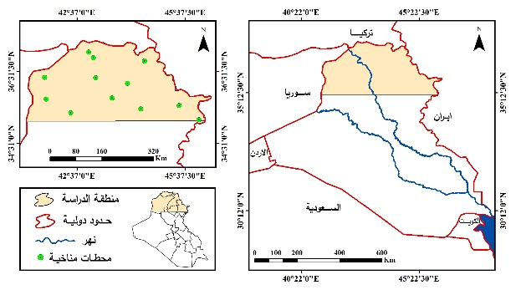
Fig. 1: In line with text………

- DISCUSSION (10 PT)
The text that is prepared on all the research and from here on, each researcher, after he writes the entire research, which he has to do, except make copies of the search as a whole and from its original file, and copy it to this file, and then format it on this file after pasting his research in it…. etc.
- Subsection title 1
Aaaaaa
- Subsection title 2
Bbbbbb
- CONCLUSION (10 PT)
The text that is prepared on all the research and from here on, each researcher, after he writes the entire research, what he has to do is make copies of the entire search and from its original file and copy it to this file and then format it on this file after pasting his research in it……. etc.
- ACKNOWLEDGEMENTS (10 PT)
Mmmmmm
- CONFLICT OF INTEREST

- REFERENCES (10 PT)
The main references are international journals and proceedings. All references should be to the most pertinent and up-to-date sources. References are written in ( ) editorial style– see examples below (9 pt):
بالنسبة للمصادر يتم كتابها كما في الصيغة التالية مع الغاء جميع الاقواس من السنوات ، وفي حال كان المصدر عربي يتم ترجمته الى اللغة الإنكليزية مع إضافة عبارة (In Arabic) في نهاية المصدر
- Abu Radi, F.A.A., 2000. Quantitative methods in geography, Alexandria, Dar Al-Marefa Al-Jami`iyyah, 493 pages. (In Arabic)
- Al-Azzawi, A.A.A., 2019. Evaluation of spatial prediction maps for rain in northern Iraq using GIS techniques, Midad Al-Adab Journal, special issue of conferences 2018-2019, pg. 941-962. (In Arabic)
- Ayad K. H., 2014. Best Distribution and Plotting Positions of Annual Rainfall in the Catchment of Holy Karbala in Iraq, Journal of Babylon University/Engineering Sciences, No. 4, Vol. 22, pp. 894-906.
- https://globalweather.tamu.edu/, Global Weather Data for SWAT, 1982-2014.
- Sanchez F.J., Chris, M.M., and Victor, J., 2013. Influence of topography on rainfall variability in Santiago Island, Cape Verde, International Journal of Climatology, pp. 1-17.

في حال كان هنالك ملحق يتم كتابته بالصيغة التالية
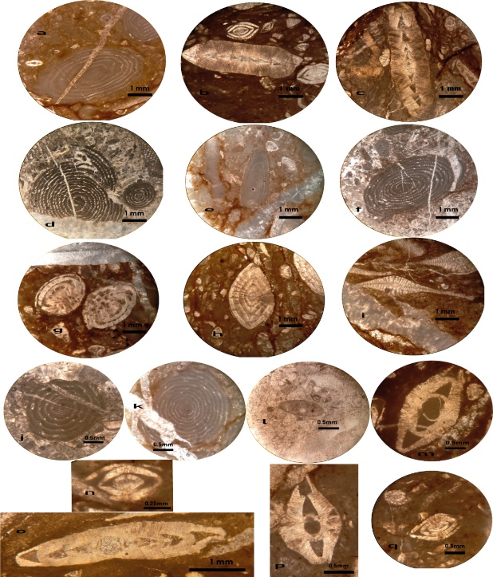
Plate 1

Plate 1: a. Alveolina elliptica (Sowerby, 1840), oblique section, sample 33; b. Assilina granulosa (d'Archiac, 1850), axial section, sample 26; c. Assilina dandotica (Davies, 1937), axial section, sample 32; d. Alveolina solida (Hottinger, 1960), axial section, sample 35; e. Alveolina frumentiformis (Schwager, 1883), oblique section, sample 33; f. Alveolina subovata (Wan, 1990), oblique section, sample 35; g. Nummulites planulatus (Lamarck, 1804), equatorial section, sample 34; h. Nummulites globulus (Leymerie, 1846), axial section, sample 30; i. Discocyclina ranikotensis (Davies, 1927), equatorial section, sample 38; j. Alveolina laxa (Hottinger, 1960), axial section, sample 1; k. Alveolina oblonga (d'Orbigny, 1826), axial section, sample 33; l. Alveolina fornasinii (Checchia-Rispoli, 1907), axial section, sample 35; m. Assilina laminosa (Gill, 1953), axial section, sample 36; n. Nummulites exilis (Douvillé, 1919), axial section, sample 30; o. Assilina spira (Roissy, 1805), axial section, sample 37; p. Assilina dandotica (Davies, 1937), axial section, sample 27; q. Nummulites mamillinus (Douvillé, 1924), axial section, sample 30.
العنوان بالعربي بنفس النمط
الباحث الأول ¹، الباحث الثاني²، الباحث الثالث³،
firstl@uomosul.edu.iq second2@uomosul.edu.iq third3@uomosul.edu.iq
¹ قسم علوم -------، كلية -------، جامعة --------، المدينة، العراق
² قسم علوم -------، كلية -------، جامعة --------، المدينة، العراق
³ قسم علوم -------، كلية -------، جامعة --------، المدينة، العراق
تاريخ الاستلام: 00- مايو-**20 تاريخ المراجعة: 00- يونيو-**20 تاريخ القبــول: 00- أغسطس-**20
تاريخ النشر الالكتروني: 00- ديسمبر -**20
الملخص (Italic, Bold, 10pt)
البحث الحالي عبارة عن دراسة تم من خلالها تشخيص وتصنيف متحجرات الاوستراكودا من مقطع تحت سطحي لتكوين هارثة (الكامبانيان المتأخر – الماسترختيان المبكر) من بئر (Ba-8) في وسط العراق. حيث تم تشخيص تسعة وخمسين نوعًا ينتمون إلى (29) جنسًا / تحت جنس من (13) عائلة، منها (57) نوعًا تُنسب إلى الأنواع الموصوفة سابقًا من الدراسات المحلية والإقليمية. تم ترك نوعين تحت التسمية الحيوانية القياسية المفتوحة بسبب نقص العينات. من خلال هذه الدراسة، كان من الواضح جدًا أن الأنواع التي تم تشخيصها ضمن تكوين هارثة هي من عمر (الكامبانيان المتأخر – الماسترختيان المبكر) وهي مشابهة جدًا من حيث المظهر الخارجي والعمر الجيولوجي لنفس الأنواع التي قورنت معها والموصوفة سابقا في مناطق شرق وغرب وشمال إفريقيا، وكذلك منطقة الخليج العربي.. (Italic, 9 pt).

الكلمات المفتاحية:
الكلمة المفتاحية الأولى : الكلمة المفتاحية الثانية : الكلمة المفتاحية الثالثة: الكلمة المفتاحية الرابعة: الكلمة المفتاحية الخامسة . (Italic, 9 SA)

DOI: *******************, ©Authors, 2026, College of Science, University of Mosul.
This is an open-access article under the CC BY 4.0 license (http://creativecommons.org/licenses/by/4.0/) .
=============================================================================

